*Housing Price Prediction Presentation*



* ***By:***

***HanXiao Zhang***

***Huimin Ou***

***Haining Fu***

Correlation matrix (heatmap style) – to help us determined what model we are going to apply

* Using this correlation matrix, we are able to visualize the raw highly influencing factors on SalePrice.
* We want to create polynomial features from the highly correlating features, in an attempt to capture the complex non-linear relationships within the data
* Correlation between 'SalePrice' and 'GrLivArea'
* Correlation between 'SalePrice' and 'GrLivArea'

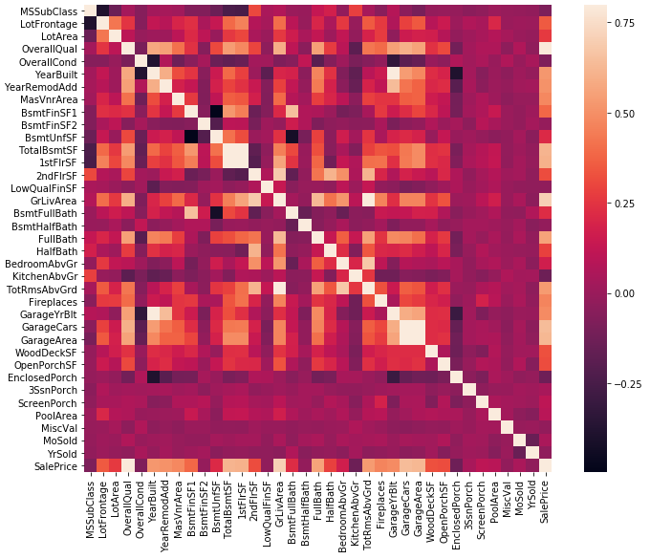

Top 10 Correlation between each features

* 'OverallQual', 'GrLivArea' and 'TotalBsmtSF' are strongly correlated with 'SalePrice'.
* We can keep 'GarageCars' since its correlation with 'SalePrice' is higher

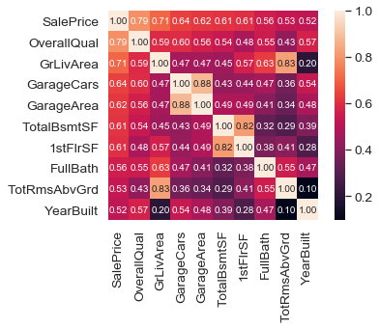

Scatter Plot display for top 10 correlated features

* A obvious linear relationship between each features

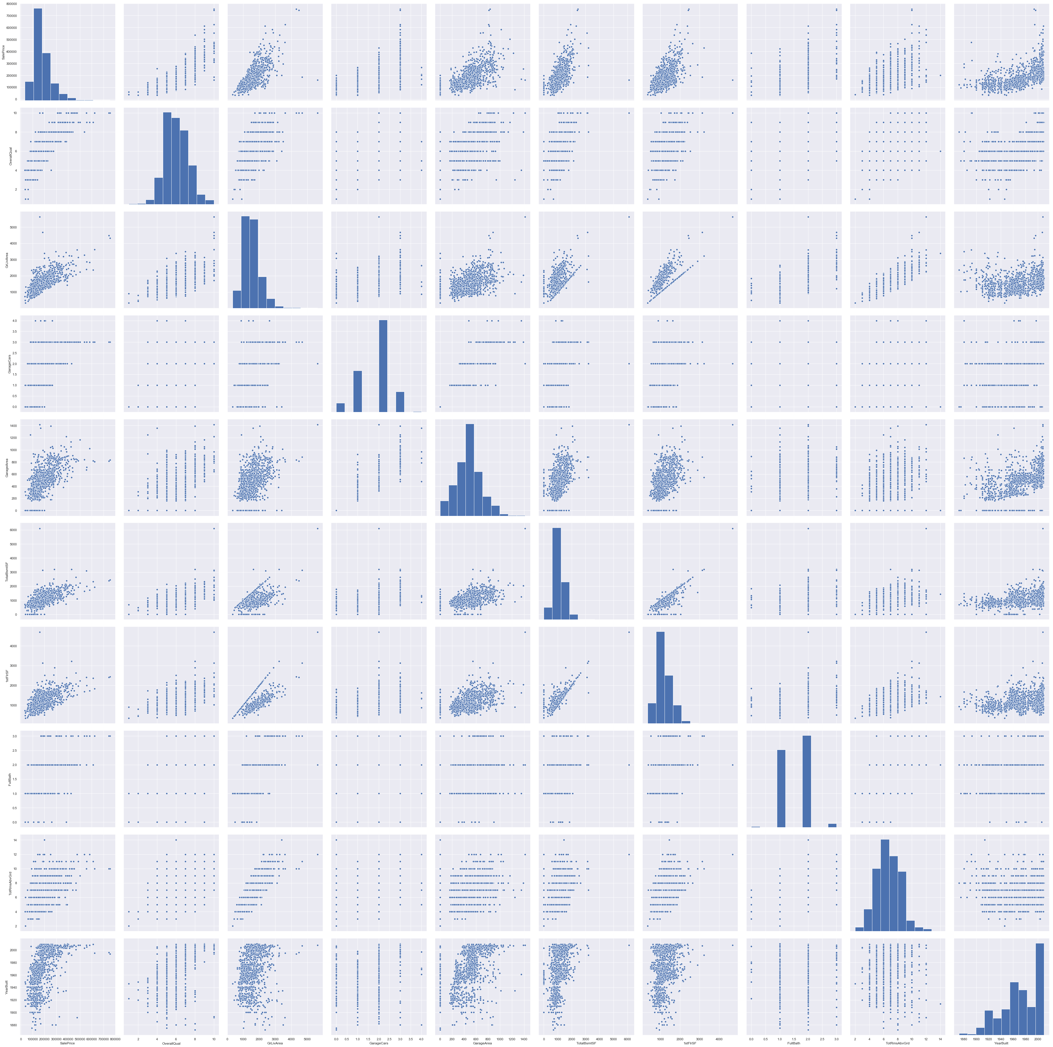

Check the Outlier

* 1. SalesPrice Vs GrLivArea

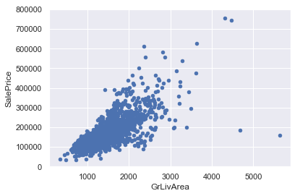

2）SalesPrice Vs TotalBsmtSF

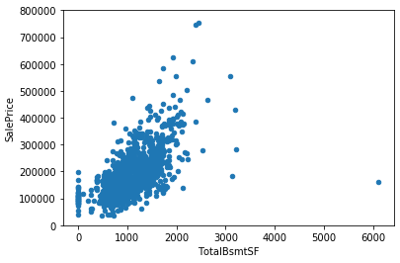

Missing Value

* List of missing Value with percentage.
* Drop all missing values with heavily weighted and with lower percentage
* For example ( PoolQC, MiscFeature and Electrical )

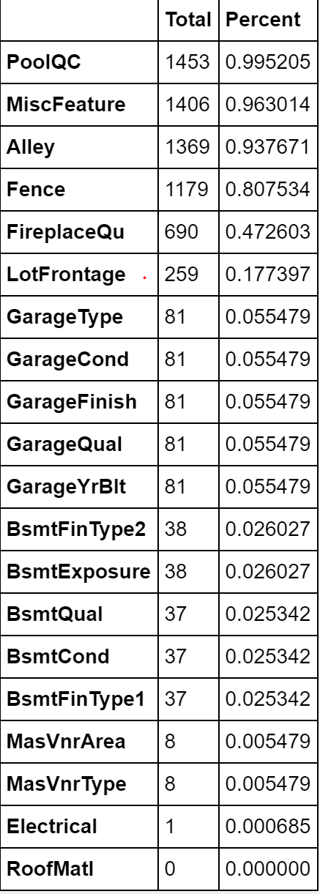

### Feature Transformation

SalePrice Distribution plot

* Deviate from the normal distribution.
* Have appreciable positive skewness.
* Show peakedness.

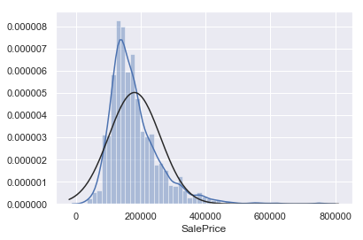

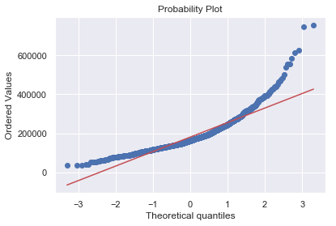

After Log Transformation

SalesPrice

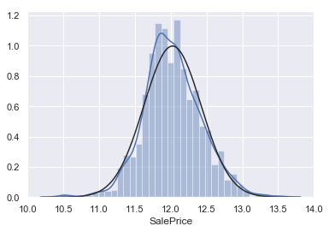

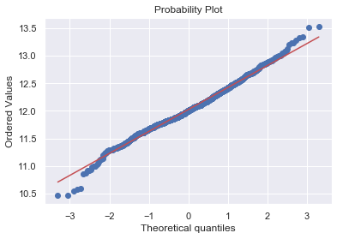

Before log Transformation:

GrLivArea

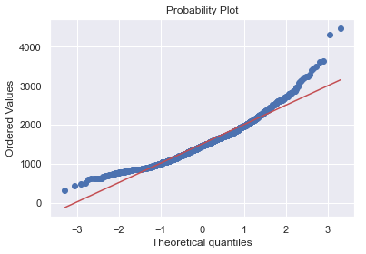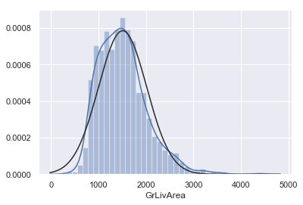

After Log Transformation

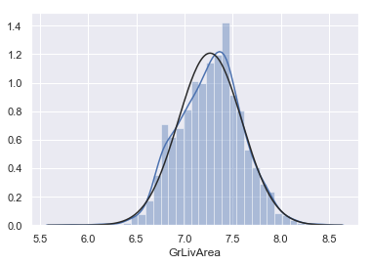

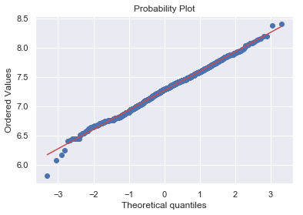

**Before the log transformation**

**TotalBsmtSF**

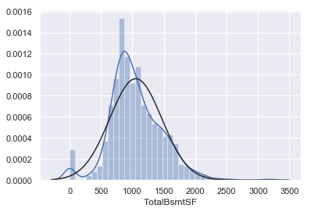

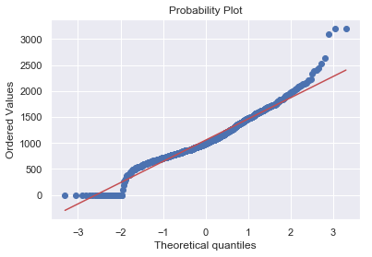

After the log Transformation

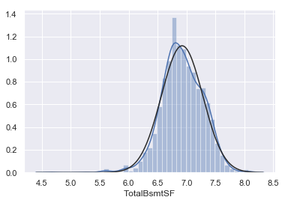

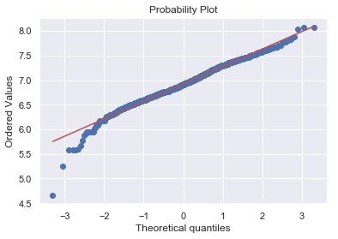

**Numeric Feature Processing**

YearBuilt

* scaler
* normalization

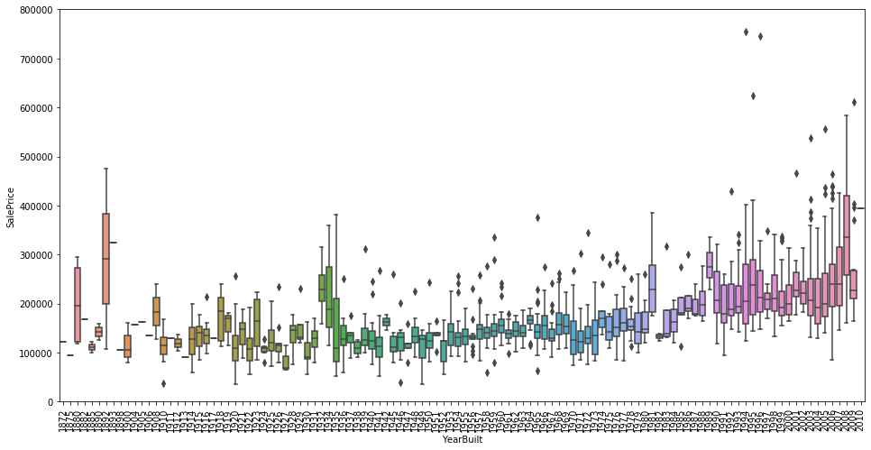

### Categorical Features Processsing

There are many categorical features, we only select the most obvious 4

* Foundation
* MasVnrType
* Exterior1st
* RoofStyle

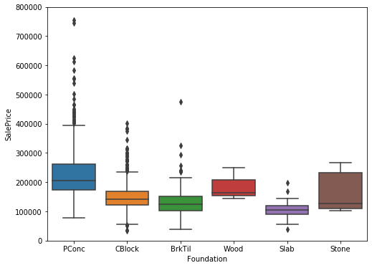

MsVnrType

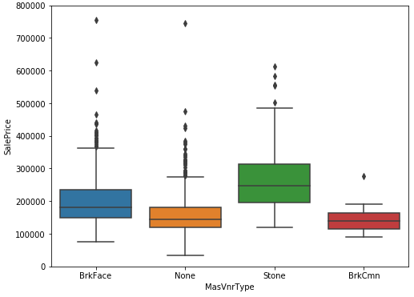

Exterior1st

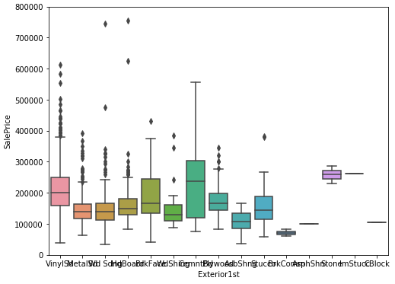

RoofStyle

`